PRACTICAL NO:-2
Configure AAA Authentication.
Diagram:-
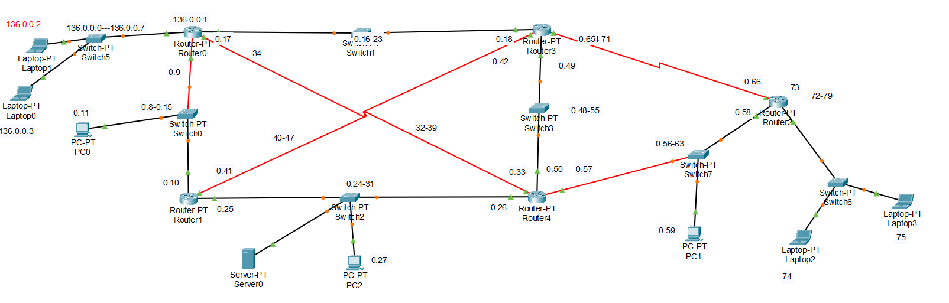
Difference Between TACACS+ and RADIUS (Simple Version)
1. Reliability
- TACACS+ → Reliable (uses TCP)
- RADIUS → Less reliable (uses UDP)
2. Encryption
- TACACS+ → Encrypts entire packet
- RADIUS → Encrypts only password
3. AAA Separation
- TACACS+ → Full AAA separation (Auth, AuthZ, Accounting)
- RADIUS → Combines Authentication + Authorization
4. Where Used
- TACACS+ → Used for router & switch admin login (network device management)
- RADIUS → Used for WiFi, VPN, and user authentication
5. Vendor Support
- TACACS+ → Cisco proprietary
- RADIUS → Open standard (works on all vendors)

1)Local AAA Authentication for Console Access on R1.
Make Router ask for a username + password when someone logs in through the console.
Commands:-
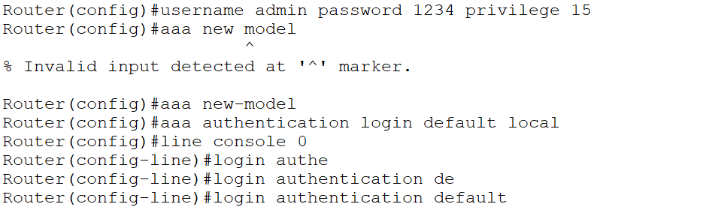
After this you have to defined username and password suppose if you first add it there will chances that it will get vanished..

Then check if it exists or not:-
AAA defines authentication rules,But lines (console, VTY) must be told to USE those rules.
Now we will verify whether the authentication is working or not:-
Now when I exit from en now the Router is asking for username and password.
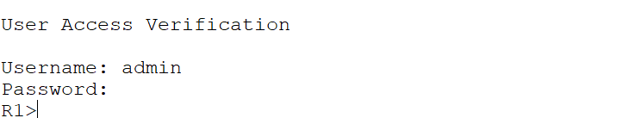

2) Configure Local AAA Authentication for VTY Lines on R1 (SSH Login).
when someone logs in remotely using SSH,This authentication must also use the local database on R1.
R1>en
R1#config terminal
Enter configuration commands, one per line. End with CNTL/Z.
R1(config)#hostname R1
R1(config)#ip domain-name example.com
R1(config)#crypto key zeroize
R1(config)#crypto key zeroize rsa
% All RSA keys will be removed.
% All router certs issued using these keys will also be removed.
Do you really want to remove these keys? [yes/no]: y
R1(config)#crypto key generate rsa
*Mar 1 1:35:59.529: %SSH-5-DISABLED: SSH 1.5 has been disabled
The name for the keys will be: R1.example.com
Choose the size of the key modulus in the range of 360 to 2048 for your
General Purpose Keys. Choosing a key modulus greater than 512 may take
a few minutes.

How many bits in the modulus [512]: 1024
% Generating 1024 bit RSA keys, keys will be non-exportable...[OK]

R1(config)#username admin secret 1234
*Mar 1 1:36:19.11: %SSH-5-ENABLED: SSH 1.99 has been enabled
R1(config)#aaa new-model
R1(config)#aaa authentication login ssh-login local
R1(config)#line vty 0 15
R1(config-line)#login authentication ssh-login
R1(config-line)#transport input ssh
R1(config-line)#
Now we can check it if is working correctly or not through pc to router:-
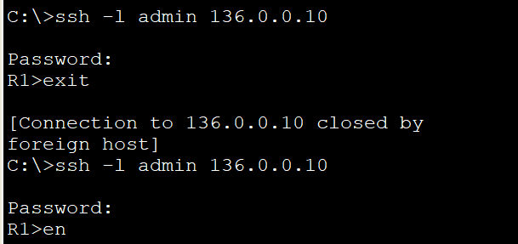
For working of en you can set it as below:-
enable secret 1234
Now enable will work easily..
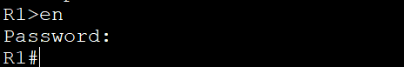

3)Configure TACACS+ AAA on Router.
Here we first defined server with ip and gateway here I defined it ip 136.0.0.30.
Now in server we will start services of AAA here the port that is defined is 1645 for radius.
First we have to find out router on which the router we will choose.
Then we have to set ip subnet mask and default gateway as follow:
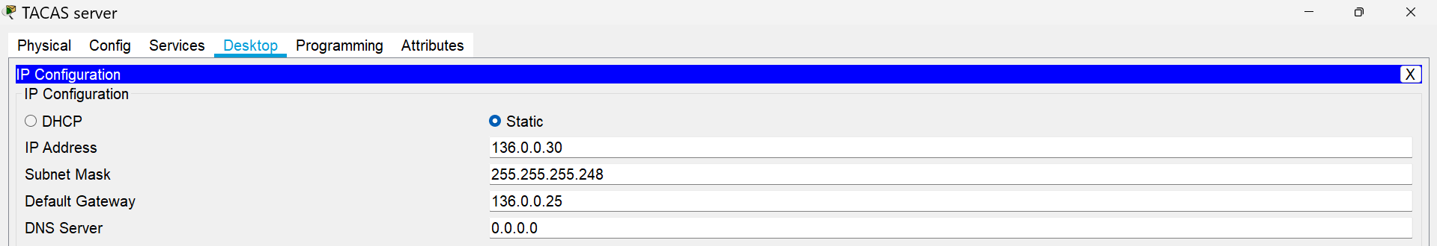
Now we will add client into network configuration.
Here
This tells the server that R3 is allowed to send authentication requests.
Client Name:
R3
(You can write any name, but “R3” makes sense)
Client IP:
R3’s IP connected to the server:
Secret:
(This must match the key you will configure on R3)
Now we will add users so that user can access them.
Here Every user added on AAA server = allowed full login if credentials match.
ALL users in the “User Setup” section are GLOBAL users.
Now we will set server so that it will authenticate logins using that RADIUS server.

We checked which IP the router uses to reach the TACACS server.
show ip route 136.0.0.30
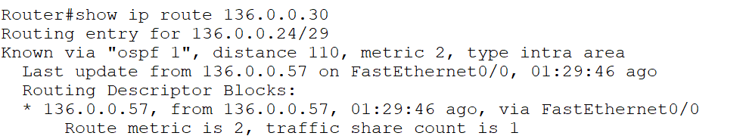
Now as defined here the that router’s network 136.0.0.56-63 is using here and router’s 136.0.0.58
Now we will use this ip for client ip for Tacacs server’s client.
And also gives any name to it and with secret key that should be same when configuring the router.
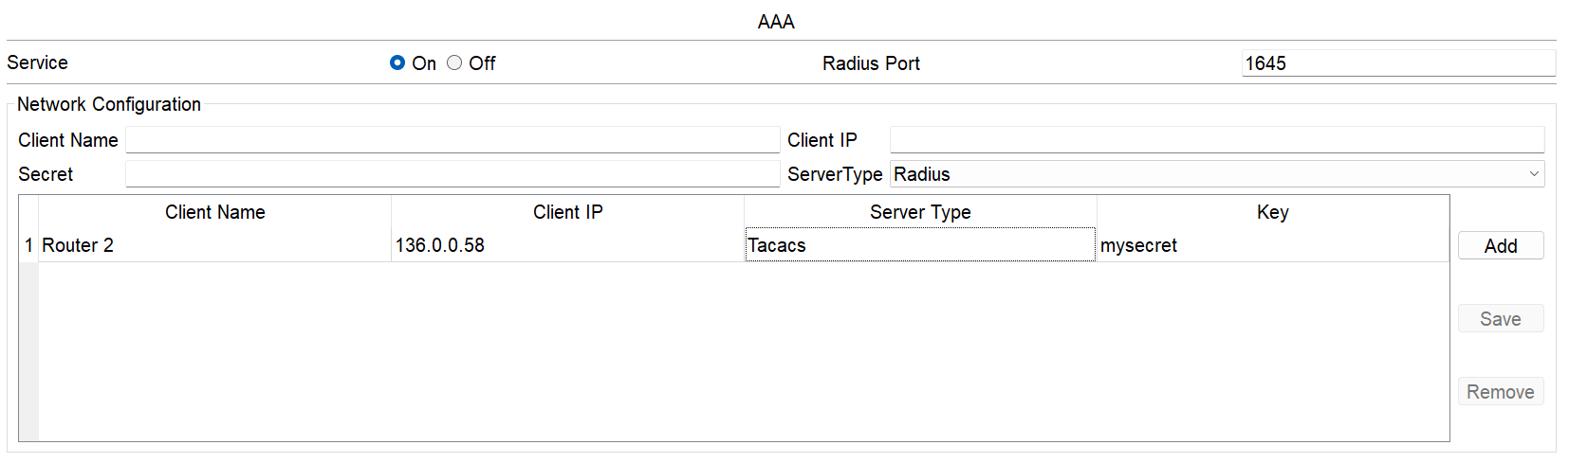
Now we will set up users which can easily login through telnet.
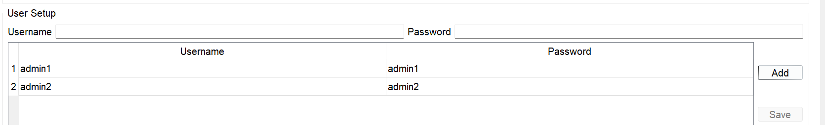
Now we will checks that anybody can easily login through telnet to this router.

Router#config terminal
Enter configuration commands, one per line. End with CNTL/Z.
Router(config)#aaa new-model
Router(config)#tacacs-server host 136.0.0.30
Router(config)#tacacs-server key mysecret
Router(config)#aaa authentication login default group tacacs+ local
Router(config)#line vty 0 15
Router(config-line)#login authentication default
Router(config-line)#transport input telnet
Router(config-line)#line console 0
Router(config-line)#login authentic
Router(config-line)#login authentication default
Router(config-line)#exit

Now for enable through telnet we use below command.
Router(config)#enable secret secret
Now we can use telnet to get remote access of that router.It is also neccassory to know that the user we defined in Tacacs+ server should not be exists in router local user,otherwise you will not able to login through that user.
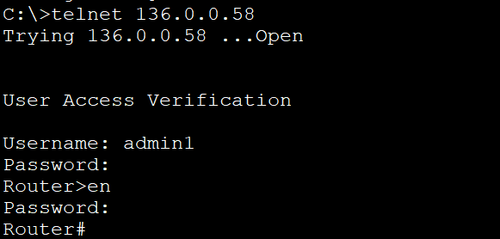

4)Configure Radius AAA on Router:
First we have to find out router on which the router we will choose.
Then we have to set ip subnet mask and default gateway as follow:

We checked which IP the router uses to reach the Radius server.
show ip route 136.0.0.30
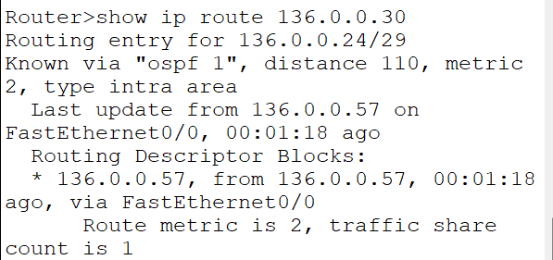
We can defined that from above that we have to defined network 56-63 to communicate here.
So we will use that ip of router’s that interface which is 136.0.0.58
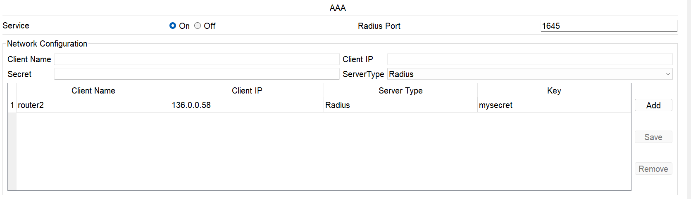

Now we will define the user that can log in here:-
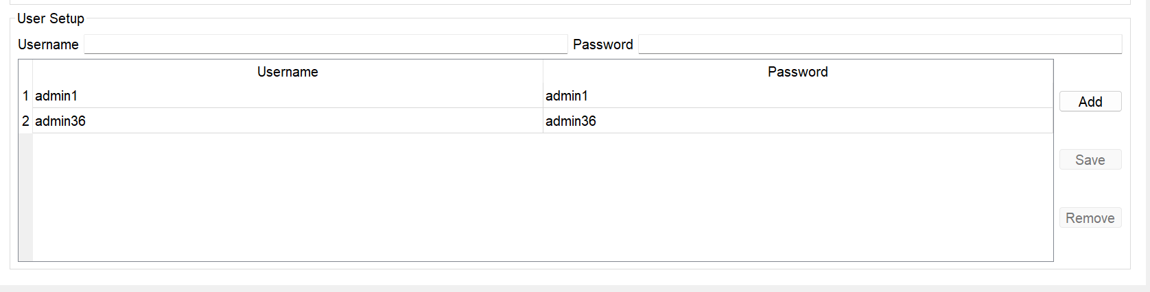
Now setup server:-

Router#conf terminal
Enter configuration commands, one per line. End with CNTL/Z.
Router(config)#aaa new-model
Router(config)#radius-server host 136.0.0.30
Router(config)#radius-server key mysecret
Router(config)#aaa authentication login default group radius local
Router(config)#line vty 0 15
Router(config-line)#login authentication default
Router(config-line)#transport input telnet
Router(config-line)#

Now we will try to connect through telnet to router.
